**Green Society Public School**

**D-10**

**Ratnanagar-7, Sauraha, Chitwan**

**Second Terminal Examination-2082**

**Class: LKG Time: - 2 hrs. F.M.: 50**

**Sub: Rhy. & Conv.**

**a) Answer the questions. (11×2=22)**

1. Where do you live?

2. What is your grandfather’s name?

3. What is your grandmother’s name?

4. What is your class teacher’s name?

5. What is your country’s name?

6. What is your school’s name?

7. What is the colour of a banana?

8. What is the colour of a leaf?

9. Name any 3 body parts?

10. Name any 3 classroom things?

11. How many hands do you have?

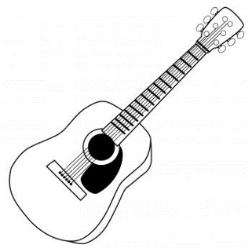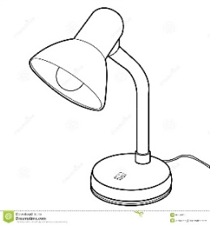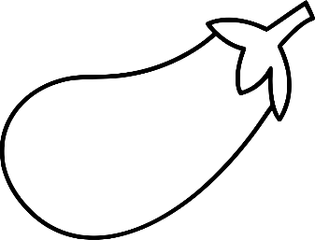**b) Name the given pictures. (8)**

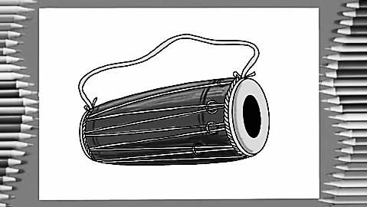

**c) Uniform (5)**

**d) Net and clean (5)**

**e) Rhymes and dance (10)**

**The End**